

**CSC584**

**ENTERPRISE PROGRAMMING**

SYSTEM: JOB RECRUITMENT MANAGEMENT SYSTEM

|  |  |
| --- | --- |
| **NAMA** | **NO. PELAJAR** |
| AMIRUL IKHWAN BIN NORDIN | 2023607574 |
| MUHAMMAD IRFAN NABIL BIN RUMIZAN | 2023680124 |
| MUHAMMAD FARHAN BIN MD FAUZI | 2023607636 |
| MUHAMMAD AMRI BIN AZRI | 2023485642 |

**DATE** **:** Week 7

**TO LECTURER**  **:** MUHAMMAD RIDHWAN MOHAMAD RAZALI

|  |  |  |
| --- | --- | --- |
| **No** | **TABLE OF CONTENT** | **Page** |
| 1 | Project Overview | 3 |
| 2 | Objective | 4 |
| 3 | Object Model Diagram | 5 |
| 4 | System Flow Diagram | 6 |
| 5 | Entity Relationship Diagram (ERD) | 7 |

# 1.0 Project Overview

The **Job Recruitment Management System** is a user-friendly online platform called the Job Recruitment Management System was created to make the job application process easier for employers and candidates alike. It acts as a central location from which job searchers can quickly examine job postings, send applications, and monitor their advancement. Companies also gain from an easy way to publish job openings, handle applications, and get in touch with possible candidates.

Before allowing a registered company to use the platform, the administrative panel of the system verifies the company's legitimacy. By confirming that the businesses advertising job vacancies are real, this verification procedure fosters trust among prospective employees. Additionally, the systems will keep things safe by making sure that people's information is safe and private.

The Job Recruitment Management System provides a smooth experience for organizations and candidates by organizing all relevant job-related data in one location. The system's goal is to transform the hiring process by emphasizing transparency, user-friendliness, and credibility while increasing accessibility for all parties involved.

# Objective

* **To Ease Job Applications**: The main goal is to make it simple for people to apply for jobs. They can easily look for jobs, apply, and see how their application is going.

* **To simplify Job Postings:** For companies, the aim is to make it easy to post job openings. They can sign up, post jobs, and manage applications without any problem.
* **All Information in One Place:** Keep all job postings, candidate profiles, and company info in one place. This makes it quick for everyone to find what they need.

# Object Model Diagram

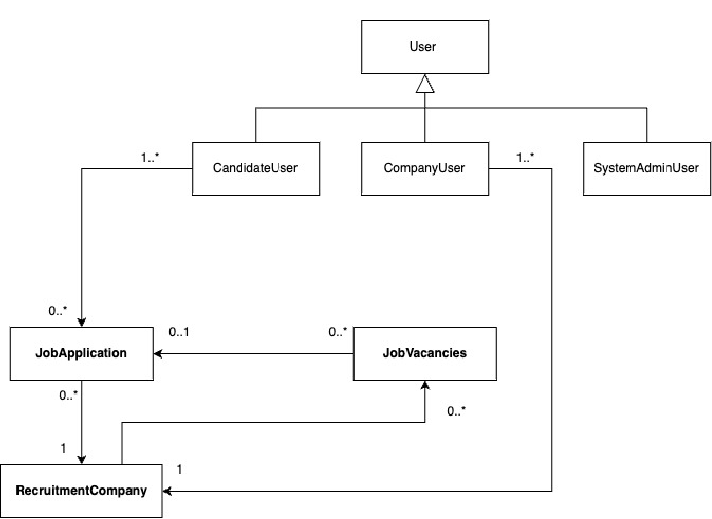

# System Flow & Activity Diagram

# Entity Relationship Diagram (ERD)

|  |
| --- |
|  |